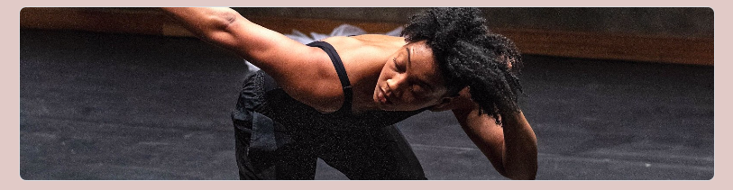
Call for Dance and Movement Artists
NEW CREATION PROJECT WITH SYREETA HECTOR

Mocean Dance is pleased to be commissioning a new work by NB-born, Toronto-based choreographer, Syreeta Hector, and we are seeking three to four dance / movement artists to participate in this new creation. This new, 20-minute work will be created in a hybrid virtual/in-person format from Nov. 2021-April 2022 and will premiere as part of Mocean’s 20th Anniversary Mainstage at Alderney Landing Theatre April 7-9, 2022.

We welcome and strongly encourage people from all communities and intersecting identities to apply. This includes Indigenous people, LGBTQ+ & Two-Spirit people, Black people and people of colour.

Syreeta will review applications and selected artists will be invited to an in-person audition on Sept 11-12 in Halifax. Artists will be informed of audition invitations by Wednesday, Sept. 1, 2021, at which point an audition date and time will be scheduled.

Eligibility: Project is open to professional dance or movement artists based in Nova Scotia. Dance artists from all forms/styles are encouraged to apply.

PLEASE NOTE: The EOI may take any form (letter, video, audio recording)—For information or application assistance please email Julie Robert, Interim Artistic Producer, producer@moceandance.com
About Syreeta Hector:

As a highly accomplished performer, Syreeta has worked for internationally recognized companies like Adelheid Dance Projects, Danny Grossman Dance Company, Peggy Baker Dance Projects, and Toronto Dance Theatre. She is a proud graduate of The National Ballet School’s Teacher Training Program, The School of Toronto Dance Theatre, and has achieved her Master of Arts in Dance Studies from York University. Her work called “Black Ballerina” focuses on the dualities within one's identity, along with Syreeta’s blackness and indigeneity in relationship to classical ballet. Syreeta is currently one of the Luminato Artists in Residence and part of the Creative Incubator at the Citadel + Compagnie.

About the work:

Syreeta’s latest work is a hybrid performance piece that blends ballet, modern dance and street dance styles. It oscillates between being physically challenging to having slow hypnotic smooth phrases. The work can go from athletic repetitive movements to explosive unpredictable choices. Her work navigates between choreographed movement and improvisational tasks. We are looking for versatile performers with a dance and/or theatre background. The desire to be physical and the ability to collaborate regarding ideas, movement, and text will be an asset.

This collaborative group piece will explore the personal versus performative identity. This performance will consider the oppositional pulls that come along with these layers of the self and will explore how we decide to bring it all to the table or leave a part of oneself behind. Questions like: Who am I? Where are we today? What do we do in order to move forward? Will all be considered in this movement process and performance.

About Mocean Dance
Mocean Dance is an award-winning contemporary dance company based in k'jipuktuk/Halifax, Nova Scotia. Led by Co-Artistic Directors Susanne Chui and Sara Coffin, Mocean commissions Canadian and international choreographers to create dance that is highly physical, collaborative, and technically and emotionally rich. Recognized nationally as a leading dance company from the Atlantic region, the company was honoured with The Lieutenant Governor of Nova Scotia Masterworks Art Award in 2016 for Canvas 5 x 5, which was the first time this esteemed provincial award was given to a Nova Scotia dance work. Founded in 2001 by Carolle Crooks Fernando, Sarah Rozee, Sara Harrigan, Alicia Orr MacDonald, and Lisa Phinney Langley, and a resident company of Halifax Dance since 2002, Mocean is committed to its home base in Nova Scotia, contributing to the province’s dance and arts community by providing opportunities for creation, performance, collaboration, development and education. www.moceandance.com

Mocean Dance creates, collaborates, and performs in Mi’kma’ki, the ancestral home and unceded territory of the Mi’kmaq people. We have gratitude for this land, and respect and appreciation for its many generations of caretakers. As an organization, we commit to learning what it means to be Treaty People who move forward together in peace and friendship.
GOOGLE FORM QUESTIONS

CONTACT INFORMATION

Name:
Pronouns:
DOB (MM/DD/YY):
Email Address:
Home Address:
Phone Number:

EXPRESSION OF INTEREST

- Background – please provide a brief introduction and summary of your experience as a dance or movement-based artist (~ 300 words)
- Please share a summary of your working practice as a dance/movement artist. This could include what excites you, what do you consider your movement qualities/affinities and strengths as a dancer/interpreter/collaborator, how do you work in the studio, what ignites your curiosity within the creative process?
- Please tell us about your interest in this creation project with Syreeta Hector:
- Please include up to 3 video links of your work (with passwords):
- Please send your 2-page CV or Bio (max 500 wrd) to Julie at: producer@moceandance.com

